
Lab Report
Submitted to:
Niaz Ashraf Khan
Submitted By:
Name:Md.Delwar Hossain Alvi
ID:222014095
Program: cse1202
Sec: 03
Date of Submission : 01 January 2023
Online banking system
An online banking system is a software application that allows users to access their bank accounts and perform various financial transactions over the internet.Some examples of operations that an online banking system might support include:
Viewing account balances and transaction history ,making deposits and withdrawals,transferring money between accounts ,paying bills online,setting up automatic payments viewing and downloading account statements.Online banking system offer a number of benefits to both customers and banks .For customers ,online banking allows them to manage their finances from anywhere with an internet connection ,saving them time and making it more convenient to stay on top of their accounts.For banks,online banking systems can reduce operational costs and improve efficiency by automating many tasks that would otherwise need to be performed manually.
Structure of this program:
The code first includes several header files: stdio.h, string.h, and stdlib.h. These header files provide functions for input and output, string manipulation, and general utility functions, respectively.

The code defines a structure called user, which represents a user of the banking system. This structure has four fields: phone, which is a string to store the user's phone number; ac, which is a string to store the user's account number; password, which is a string to store the user's password; and balance, which is a float to store the user's current account balance.

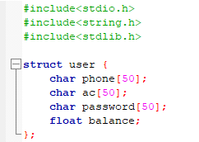

The code defines a function called main, which is the entry point of the program. This function first declares several variables: usr and usr1, which are structures of type user; fp, which is a pointer to a file; filename, which is a string to store the name of a file; phone and pword, which are strings to store a phone number and password, respectively; opt, which is an integer to store the user's choice of action; choice, which is an integer to store the user's choice of banking function; and amount, which is a float to store an amount of money.

The program prints a menu for the user to choose what action they want to take: either register a new account or log in to an existing account. The user inputs their choice and it is stored in the variable opt.

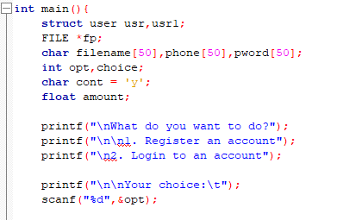

If the user chose to register a new account (i.e., opt is equal to 1), the program prompts the user to enter their account number, phone number, and password, and creates a new user structure with these values. The balance field is set to 0. The program then creates a new file with the name [phone number].dat (e.g., 1234567890.dat if the phone number is 1234567890) and writes the user structure to this file. If the write operation is successful, the program prints a message indicating that the account was successfully registered. If the write operation fails, the program prints a message indicating that something went wrong.

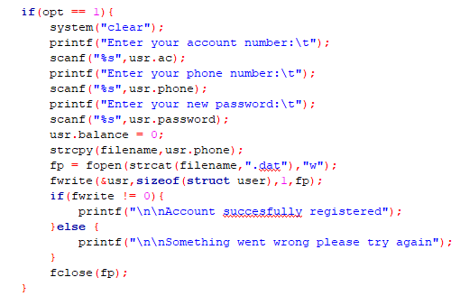

If the user chose to log in to an existing account (i.e., opt is equal to 2), the program prompts the user to enter their phone number and password and stores these values in the variables phone and pword, respectively. The program then tries to open the file [phone number].dat for reading. If the file does not exist (i.e., the fp pointer is equal to NULL), the program prints a message indicating that the account is not registered. If the file exists, the program reads the user structure from the file and stores it in the usr variable. The program then checks if the password entered by the user matches the password stored in the usr structure. If the passwords match, the program prints a welcome message and enters a loop that allows the user to perform various banking functions. If the passwords do not match, the program prints a message indicating that the login has failed.
Inside the loop, the program prints a menu of banking functions and prompts the user to choose

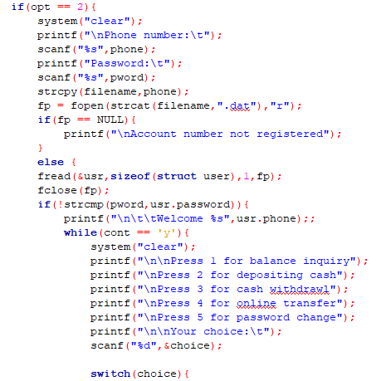

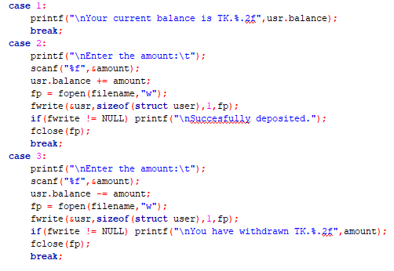

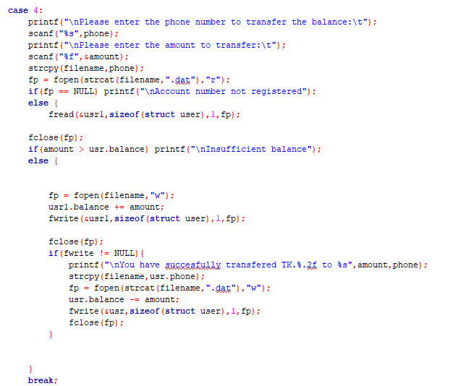

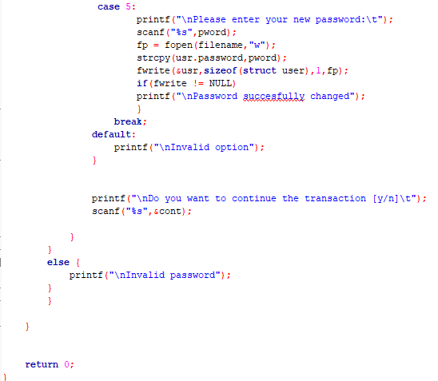

Output:
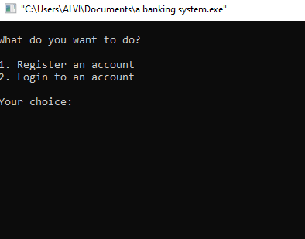
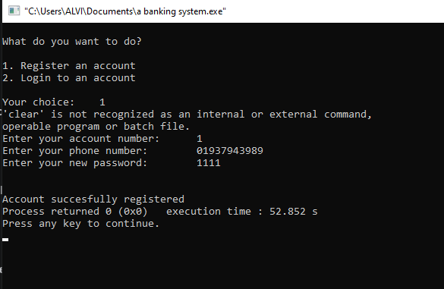
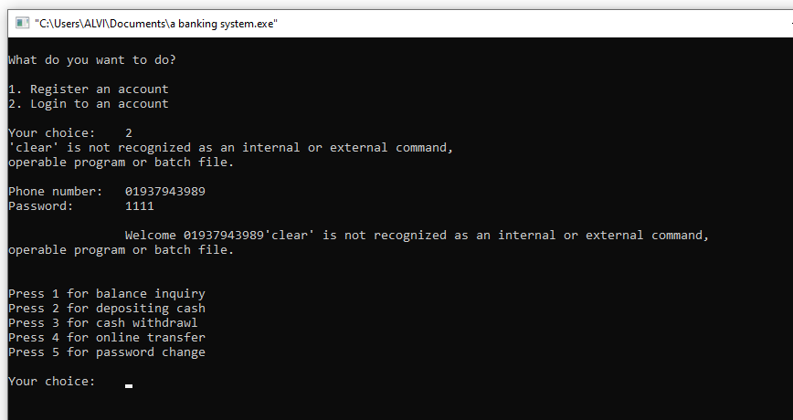

Conclusion:
Online banking system are a valuable tool for both customers and banks ,offering convenient and efficient access to financial services .while there are risks and challenges to consider ,these can be mitigated through the use of appropriate security measures.

